Assignment 11

Name – Abhishek Agrahari

Roll Number 190123066

Question 1

Mixture PDF = f(x) = $\sum_{k=1}^{3}{π_{i}\frac{1}{σ_{i}}ϕ\left(\frac{x-μ_{i}}{σ_{i}}\right)}$ = $\sum_{k=1}^{3}{π_{i}f_{i}(x)}$

where fi is PDF of N () and

(µ1, µ2, µ3) = (-1,0,1)

(σ1, σ2, σ3) = (1/4,1,1/2)

(π1, π2, π3) = (1/2, 1/3, 1/6)

Average of generated random numbers = -0.33683669692866525

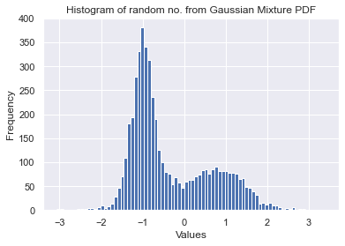

Question 2

Taking ti = i/1000 generated W(t) for time interval [0,5] from the following formula-

$$W\left(t_{i+1}\right)=W\left(t_{i}\right)+\sqrt{t_{i+1}-t_{i}}{ Z}_{i+1}$$

where Zi are independent standard normal and W (0) = 0

Estimated values of E [W (2)] and E [W (5)] are given below-

E [W (2)] = -0.14948703718606832

E [W (5)] = -0.5467512325552152

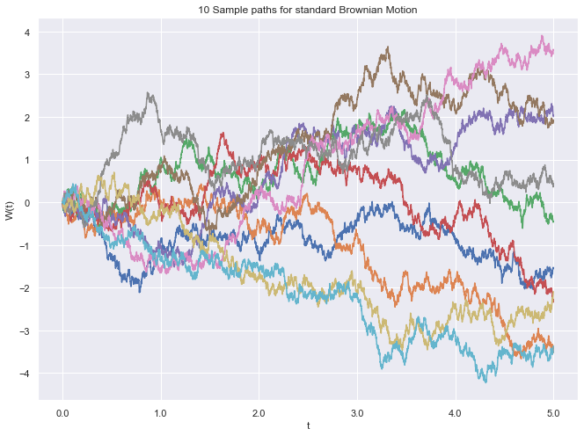

Question 3

Taking ti = i/1000 generated X(t) for time interval [0,5] from the following formula-

$$X\left(t_{i+1}\right)=X\left(t_{i}\right)+μ (t_{i+1}-t_{i})+σ\sqrt{t_{i+1}-t_{i}}{ Z}_{i+1}$$

where Zi are independent standard normal and X (0) = 5 and µ = 0.06 and σ = 0.3.

Estimated values of E [X (2)] and E [X (5)] are given below-

E[X(2)] = 4.904035253073413

E[X(5)] = 4.9971940234649415

